Programming Assignment #3
Name: Amna Malik ID: R11827604
Problem-1
(Your Codes)
package parts.part1;
import java.util.Scanner;
/**
* DriverExam models a 20-question driver's license exam.
* It stores correct answers, student answers, grading results,
* and provides methods to report pass/fail and missed questions.
*/
class DriverExam {
// Stores the correct answers for the 20-question exam.
private char[] correctAnswers;
// Stores the student's answers for the 20-question exam.
private char[] givenAnswers;
// Stores the number of questions the student answered correctly.
private int totalCorrect;
// Stores which questions were missed (true means missed).
private boolean[] missedQuestions;
// Tracks whether grading has been performed to avoid re-grading.
private boolean isGraded;
/**
* Constructs a DriverExam with the student's answers.
* Parameters:
* - studentAnswers: a char array of length 20 containing answers A-D
* Intended use:
* - Initializes the exam with the provided student answers so it can be graded.
*/
public DriverExam(char[] studentAnswers) {
// Initializes the correct answers array with 20 entries.
correctAnswers = new char[] {
'B', 'D', 'A', 'A', 'C',
'A', 'B', 'A', 'C', 'D',
'B', 'C', 'D', 'A', 'D',
'C', 'C', 'B', 'D', 'A'
};
// Stores the student's answers.
givenAnswers = studentAnswers;
// Initializes total correct to 0 before grading.
totalCorrect = 0;
// Initializes the missed questions tracking array to length 20.
missedQuestions = new boolean[20];
// Marks the exam as not yet graded.
isGraded = false;
}
/**
* Determines whether the student passed the exam.
* Parameters:
* - none
* Intended use:
* - Grades the exam if needed, then returns true if totalCorrect >= 15, else false.
*/
public boolean passed() {
// Ensures grading is done before checking pass/fail.
gradeExam();
// Returns true if the student got at least 15 correct answers.
return totalCorrect >= 15;
}
/**
* Returns the total number of correct answers.
* Parameters:
* - none
* Intended use:
* - Grades the exam if needed, then returns the count of correct answers.
*/
public int totalCorrect() {
// Ensures grading is done before returning correct count.
gradeExam();
// Returns the total correct.
return totalCorrect;
}
/**
* Returns the total number of incorrect answers.
* Parameters:
* - none
* Intended use:
* - Grades the exam if needed, then returns 20 - totalCorrect.
*/
public int totalIncorrect() {
// Ensures grading is done before returning incorrect count.
gradeExam();
// Returns the total incorrect.
return 20 - totalCorrect;
}
/**
* Returns the question numbers that were missed as a comma-separated String.
* Parameters:
* - none
* Intended use:
* - Grades the exam if needed, then reports which question numbers were missed.
*/
public String questionsMissed() {
// Ensures grading is done before building missed list.
gradeExam();
// missedList builds a string listing missed question numbers.
StringBuilder missedList = new StringBuilder(); // missedList builds the missed question output.
// first tracks if we are adding the first missed question (comma formatting).
boolean first = true; // first is used to format commas properly.
// Loops through the missedQuestions array.
for (int i = 0; i < missedQuestions.length; i++) {
// Checks if question i was missed.
if (missedQuestions[i]) {
// Adds comma and space if not the first missed question.
if (!first) {
missedList.append(", ");
}
// Appends the question number (i + 1) because questions are 1-based.
missedList.append(i + 1);
// After adding the first item, mark first as false.
first = false;
}
}
// If nothing was missed, return "None".
if (missedList.length() == 0) {
return "None";
}
// Returns the built list.
return missedList.toString();
}
/**
* Grades the exam by comparing givenAnswers to correctAnswers.
* Parameters:
* - none
* Intended use:
* - Updates totalCorrect and missedQuestions exactly once.
*/
private void gradeExam() {
// If already graded, do nothing.
if (isGraded) {
return;
}
// Resets totalCorrect in case of any future extensions.
totalCorrect = 0;
// Compares each answer.
for (int i = 0; i < correctAnswers.length; i++) {
// Checks if the student's answer matches the correct answer.
if (givenAnswers[i] == correctAnswers[i]) {
// Increments correct count if matched.
totalCorrect++;
// Marks question as not missed.
missedQuestions[i] = false;
} else {
// Marks question as missed.
missedQuestions[i] = true;
}
}
// Marks grading as complete.
isGraded = true;
}
}
/**
* DriverExamDemo prompts the user for answers to a driver's license exam,
* validates input, and prints pass/fail results and missed questions.
*/
public class DriverExamDemo {
/**
* Program entry point.
* Parameters:
* - args: command-line arguments (unused)
* Intended use:
* - Collects 20 validated answers, creates a DriverExam, and prints results.
*/
public static void main(String[] args) {
// input reads user input from the keyboard.
Scanner input = new Scanner(System.in); // input is used to read keyboard input.
// studentAnswers stores the student's answers for all 20 questions.
char[] studentAnswers = new char[20]; // studentAnswers stores the validated exam answers.
// Loops through questions 1 to 20.
for (int i = 0; i < studentAnswers.length; i++) {
// valid stores whether the current answer is valid.
boolean valid = false; // valid controls the input validation loop.
// Re-prompts until a valid answer is entered.
while (!valid) {
// Prompts the user for the current question answer.
System.out.print("Question " + (i + 1) + " Student Answer: ");
// line stores the raw input line.
String line = input.nextLine(); // line stores the user's typed response.
// Trims whitespace and converts to uppercase to standardize.
line = line.trim().toUpperCase();
// Validates that input is exactly one character and is A-D.
if (line.length() == 1) {
// ans stores the single character answer entered.
char ans = line.charAt(0); // ans stores the validated letter candidate.
// Checks if the answer is one of A, B, C, D.
if (ans == 'A' || ans == 'B' || ans == 'C' || ans == 'D') {
// Stores the valid answer.
studentAnswers[i] = ans;
// Marks as valid to exit loop.
valid = true;
} else {
// Prints validation error when not A-D.
System.out.println("Answer Validation - Please enter A, B, C, or D.");
}
} else {
// Prints validation error when not a single character.
System.out.println("Answer Validation - Please enter a single letter A, B, C, or D.");
}
}
}
// exam creates a DriverExam object using collected answers.
DriverExam exam = new DriverExam(studentAnswers); // exam grades and reports exam results.
// Prints whether the student passed.
System.out.println("Passed: " + exam.passed());
// Prints total correct.
System.out.println("Total Correct: " + exam.totalCorrect());
// Prints total incorrect.
System.out.println("Total Incorrect: " + exam.totalIncorrect());
// Prints the question numbers missed.
System.out.println("Questions Numbers Missed: " + exam.questionsMissed());
// Closes the scanner.
input.close();
}
}

(Output- screenshots)
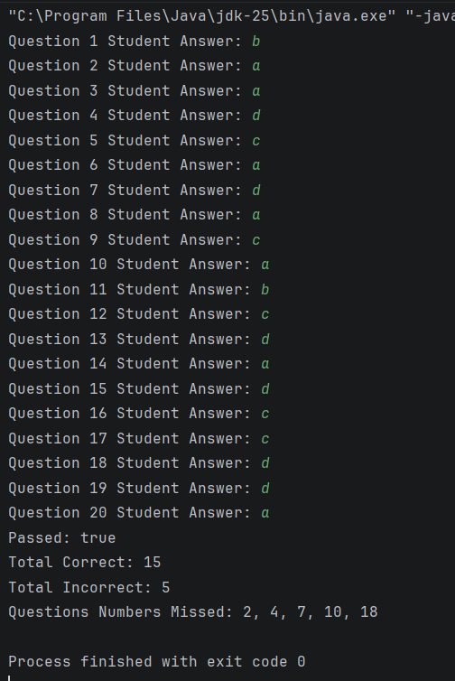
Problem-2
(Your Codes)
package parts.part2;
import java.util.Scanner;
/**
* ChargeAccountValidator validates charge account numbers by comparing
* a provided number against a list of known valid account numbers.
*/
class ChargeAccountValidator {
// Stores the list of valid charge account numbers.
private int[] validAccounts;
/**
* Constructs a ChargeAccountValidator and loads the valid account list.
* Parameters:
* - none
* Intended use:
* - Initializes the validator with the required set of valid account numbers.
*/
public ChargeAccountValidator() {
// Initializes the array of valid charge account numbers.
validAccounts = new int[] {
5658845, 4520125, 7895122, 8777541, 8451277, 1302850,
8080152, 4562555, 5552012, 5050552, 7825877, 1250255,
1005231, 6545231, 3852085, 7576651, 7881200, 4581002
};
}
/**
* Determines whether an account number is valid using linear search.
* Parameters:
* - accountNumber: the account number to validate
* Intended use:
* - Returns true if accountNumber exists in validAccounts, otherwise false.
*/
public boolean isValid(int accountNumber) {
// Loops through each valid account number.
for (int i = 0; i < validAccounts.length; i++) { // i is the index used to search the array.
// Checks if the current stored account matches the input.
if (validAccounts[i] == accountNumber) {
// Returns true immediately if found.
return true;
}
}
// Returns false if the number was not found.
return false;
}
}
/**
* ChargeAccountDemo prompts the user to enter an account number and
* reports whether it is valid using ChargeAccountValidator.
*/
public class ChargeAccountDemo {
/**
* Program entry point.
* Parameters:
* - args: command-line arguments (unused)
* Intended use:
* - Reads an account number from the user with validation and prints valid or invalid.
*/
public static void main(String[] args) {
// input reads user input from the keyboard.
Scanner input = new Scanner(System.in); // input is used to read keyboard input.
// validator checks whether an account number exists in the valid list.
ChargeAccountValidator validator = new ChargeAccountValidator(); // validator performs the validation.
// accountNumber stores the numeric account number entered by the user.
int accountNumber = 0; // accountNumber holds the user's valid integer input.
// isInputValid controls the input validation loop.
boolean isInputValid = false; // isInputValid is true only after a valid integer is read.
// Keeps asking until a valid integer is entered.
while (!isInputValid) {
// Prompts the user to enter an account number.
System.out.print("Enter a charge account number: ");
// Checks whether the next token is an integer.
if (input.hasNextInt()) {
accountNumber = input.nextInt();
isInputValid = true;
} else {
// badInput stores the invalid token so we can consume it.
String badInput = input.next(); // badInput removes the invalid entry from the scanner.
System.out.println("Invalid input. Please enter a numeric charge account number.");
}
}
// valid stores whether the account number exists in the list.
boolean valid = validator.isValid(accountNumber); // valid is true if accountNumber was found.
// Prints the appropriate result message.
if (valid) {
System.out.println("Valid, the charge account number exists.");
} else {
System.out.println("Invalid, the charge account number does not exist.");
}
// Closes the scanner.
input.close();
}
}

(Output- screenshots)
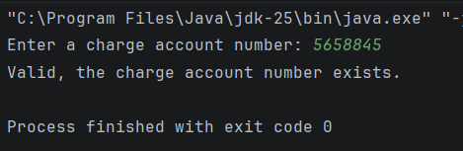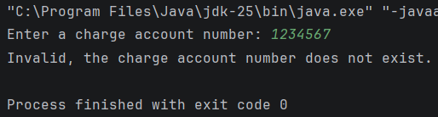

Problem-3
(UML-screenshots)
